Homework 1

313581038 智能所碩一 蒲品憶

1. **Discuss different treatments of different Bayer patterns when:**
2. **applying white balance mask into original image.**
3. **ii. doing mosaic algorithm.**
4. **applying white balance mask into original image.**

White balance is used to adjust the colors of an image to make it look more natural, typically to correct color shifts in the image (for example, images taken under different lighting conditions may have a red or blue tint). Since the human eye is most sensitive to green, the green channel's intensity is usually kept unchanged in image processing because it has the greatest impact on the overall visual effect.

Set Green: to 1

Set Red: to fr

Set Blue: to fb

**RGGB**: **GRBG**:

|  |  |
| --- | --- |
| fr | 1 |
| 1 | fb |

|  |  |
| --- | --- |
| 1 | fr |
| fb | 1 |

**GBRG**: **BGGR**:

|  |  |
| --- | --- |
| 1 | fb |
| fr | 1 |

|  |  |
| --- | --- |
| fb | 1 |
| 1 | fr |

Image:

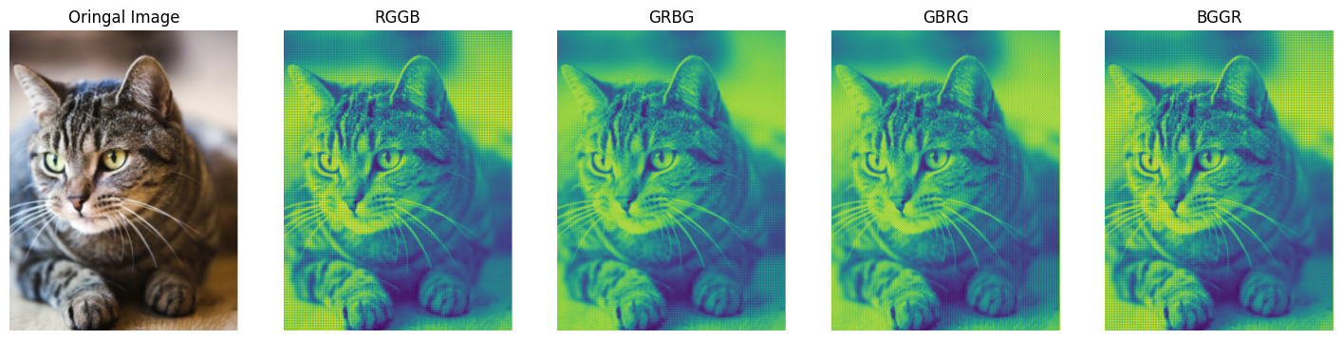

**Since there are two green channels, the overall image tends to have a greenish bias.**

1. **doing mosaic algorithm.**

Each pixel has three channels: RGB. Two of the channels are removed, and one channel is retained as the representative. The channel to retain is determined by the Bayer pattern.

In the table below:

Numbers represent: Height x Width x Channel

Letters represent: Red (R), Blue (B), Green (G)

**RGGB**:

|  |  |  |  |  |  |
| --- | --- | --- | --- | --- | --- |
| R 000 | G 001 | B 002 | R 010 | G 011 | B 012 |
| R 100 | G 101 | B 102 | R 110 | G 111 | B 112 |

**GRBG**:

|  |  |  |  |  |  |
| --- | --- | --- | --- | --- | --- |
| R 000 | G 001 | B 002 | R 010 | G 011 | B 012 |
| R 100 | G 101 | B 102 | R 110 | G 111 | B 112 |

**GBRG**:

|  |  |  |  |  |  |
| --- | --- | --- | --- | --- | --- |
| R 000 | G 001 | B 002 | R 010 | G 011 | B 012 |
| R 100 | G 101 | B 102 | R 110 | G 111 | B 112 |

**BGGR**:

|  |  |  |  |  |  |
| --- | --- | --- | --- | --- | --- |
| R 000 | G 001 | B 002 | R 010 | G 011 | B 012 |
| R 100 | G 101 | B 102 | R 110 | G 111 | B 112 |

The color as the background indicates which channel is selected as the representative for the pixel.

Image:



1. **Show the image results of each step as p.6/7 in HW1.pdf.**

* **Inverse ISP**

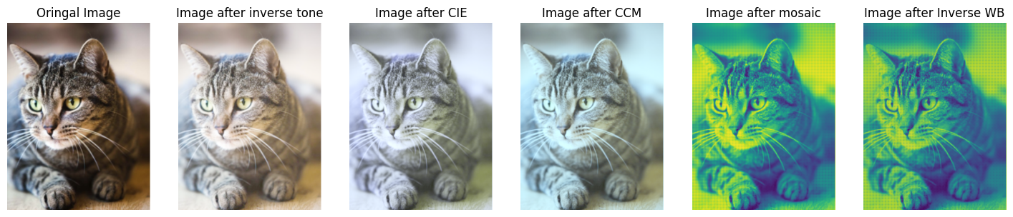

* **ISP**

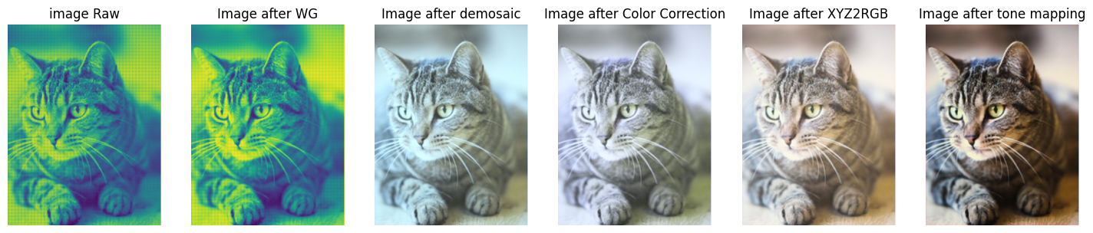

1. **Show the image results of inverse ISP and ISP as p.19 in HW1.pdf. Additionally, compare the performance results of this task using PSNR.**

* Origin image and After process image

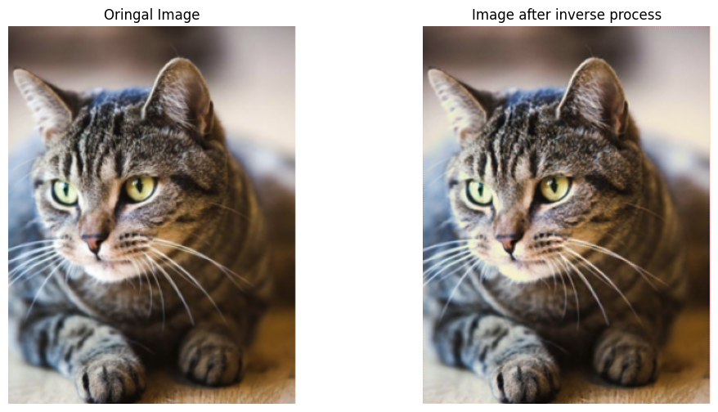

* PSNR score

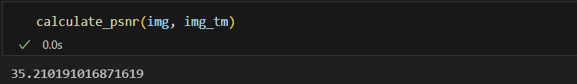

1. **In recent AI de-noising methods, in order to generate paired data for training, we will add synthetic noise to clean image on RAW domain instead of RGB domain. Explain the reason.**
2. RAW is the most original data: RAW data is closer to the original output from the camera's sensor, and it hasn't undergone internal camera processing (such as white balance, color enhancement, etc.). This allows it to more accurately reflect the shooting conditions.
3. Noise originates at the RAW level: Noise is primarily generated at the sensor level, rather than in the RGB color space. RAW data contains the sensor's original data, so adding noise in the RAW domain more accurately simulates the noise characteristics in real-world environments.
4. Preserving more details: Adding noise directly to the RAW image, rather than on the RGB image, preserves more details and is closer to the actual camera capturing process. This makes the training data more reflective of real-world scenarios.

Based on the above points, in AI training, we add noise to the RAW data as training data to make the training data closer to real-world conditions.